FAST National University
Of Computing And Emerging Sciences
Software Design and Architecture (SDA)
Assignment Task 1
University Fuel Management System
Requirement Elicitation and Documentation
Group Members
Saad Ahmed Ijaz (Roll No: 24P-0669)
Arif Ali (Roll No: 0736)
Arslan Tariq (Roll No: 24P-0610)
Submitted To:
Professor Umer Haroon
Date: March 2026

Table of Contents
(Right-click and select Update Field to refresh page numbers)

1. Introduction 3
2. Stakeholders 3
3. Functional Requirements 4
4. Non-Functional Requirements 7
5. Use Case Diagram 8
6. Use Case Specifications 9
7. Class Diagram 12
8. Conclusion 13

1. Introduction
The University Fuel Management System is a software solution designed to efficiently manage and track fuel consumption for all university vehicles. This system aims to replace manual record-keeping methods with an automated, digital approach that ensures accuracy, transparency, and ease of access.
FAST National University Of Computing And Emerging Sciences operates a fleet of vehicles including buses for student transportation, administrative vehicles, and maintenance vehicles. Managing fuel for these vehicles manually has proven to be inefficient and prone to errors. The proposed system will streamline fuel management processes, reduce costs, and provide comprehensive reporting capabilities.
The primary objectives of this system are to:
1.Automate fuel tracking and management processes
2.Provide real-time monitoring of fuel consumption
3.Generate accurate reports for administrative purposes
4.Reduce fuel wastage and identify cost-saving opportunities
5.Maintain a centralized database of all fuel-related transactions
6.Ensure accountability through driver and vehicle tracking

2. Stakeholders
The following stakeholders have been identified for the University Fuel Management System:
Stakeholder | Role | Responsibilities
Drivers | Primary Users | Request fuel, report mileage, update vehicle status
Fuel Station Attendants | Operational Users | Dispense fuel, record transactions, verify driver credentials
Transport Admin | Managerial Users | Manage vehicles, approve fuel requests, monitor consumption
Finance Department | Financial Oversight | Review expenses, approve budgets, process payments
System Administrator | Technical Management | Manage user accounts, system configuration, data backup
University Management | Decision Makers | Review reports, make policy decisions, approve major expenses
Table 1: System Stakeholders

3. Functional Requirements
The following functional requirements have been identified for the University Fuel Management System:
ID | Requirement | Description
FR-01 | User Authentication | The system shall provide secure login functionality for all users with role-based access control.
FR-02 | Vehicle Registration | The system shall allow administrators to register new vehicles with details including make, model, registration number, and fuel capacity.
FR-03 | Driver Registration | The system shall maintain driver profiles including personal information, license details, and assigned vehicles.
FR-04 | Fuel Request | Drivers shall be able to submit fuel requests through the system specifying vehicle ID and estimated quantity.
FR-05 | Fuel Approval | Transport admin shall review and approve/reject fuel requests based on vehicle schedule and consumption history.
FR-06 | Fuel Dispensing | Fuel station attendants shall record fuel dispensing transactions with quantity, date, time, and odometer reading.
FR-07 | Odometer Entry | The system shall capture odometer readings at the time of fueling to calculate fuel efficiency.
FR-08 | Fuel Stock Management | The system shall track fuel stock levels at the university fuel station and alert when replenishment is needed.
FR-09 | Daily Reports | The system shall generate daily fuel consumption reports showing total fuel dispensed and vehicle-wise breakdown.
FR-10 | Monthly Reports | The system shall generate monthly summary reports for management review and budget planning.
FR-11 | Vehicle-wise Reports | The system shall provide detailed fuel consumption reports for individual vehicles over specified time periods.
FR-12 | Driver-wise Reports | The system shall generate reports showing fuel consumption patterns by individual drivers.
FR-13 | Route Management | The system shall maintain records of regular routes for each vehicle to estimate fuel requirements.
FR-14 | Maintenance Alerts | The system shall alert when vehicles are due for maintenance based on mileage or time intervals.
FR-15 | Fuel Efficiency Calculation | The system shall automatically calculate and display fuel efficiency (km per liter) for each vehicle.
FR-16 | Cost Tracking | The system shall track fuel costs and maintain historical price data for budget analysis.
FR-17 | Budget Monitoring | The system shall compare actual fuel expenses against allocated budgets and alert when thresholds are exceeded.
FR-18 | Search Functionality | The system shall provide search capabilities to find transactions by vehicle, driver, date range, or transaction ID.
FR-19 | Data Export | The system shall allow exporting reports in common formats (PDF, Excel) for external use.
FR-20 | Notification System | The system shall send notifications for pending approvals, low stock alerts, and maintenance reminders.
FR-21 | Audit Trail | The system shall maintain a complete audit trail of all transactions including user actions and timestamps.
FR-22 | Backup and Recovery | The system shall provide automated data backup and recovery mechanisms.
Table 2: Functional Requirements

4. Non-Functional Requirements
The following non-functional requirements define the quality attributes of the University Fuel Management System:
ID | Category | Requirement
NFR-01 | Performance | The system shall respond to user queries within 2 seconds under normal load conditions.
NFR-02 | Performance | The system shall support up to 50 concurrent users without performance degradation.
NFR-03 | Availability | The system shall maintain 99.5% uptime during operational hours (6 AM to 10 PM).
NFR-04 | Security | All user passwords shall be encrypted using industry-standard hashing algorithms.
NFR-05 | Security | The system shall implement session timeout after 15 minutes of inactivity.
NFR-06 | Usability | The user interface shall be intuitive and require minimal training for basic operations.
NFR-07 | Usability | The system shall provide clear error messages and guidance for error recovery.
NFR-08 | Scalability | The system architecture shall support future expansion to accommodate up to 200 vehicles.
NFR-09 | Reliability | The system shall not lose any transaction data in case of unexpected failures.
NFR-10 | Maintainability | The system code shall be well-documented to facilitate future modifications and updates.
NFR-11 | Portability | The system shall be accessible through web browsers on both desktop and mobile devices.
NFR-12 | Data Integrity | The system shall implement data validation to prevent incorrect or duplicate entries.
Table 3: Non-Functional Requirements

5. Use Case Diagram
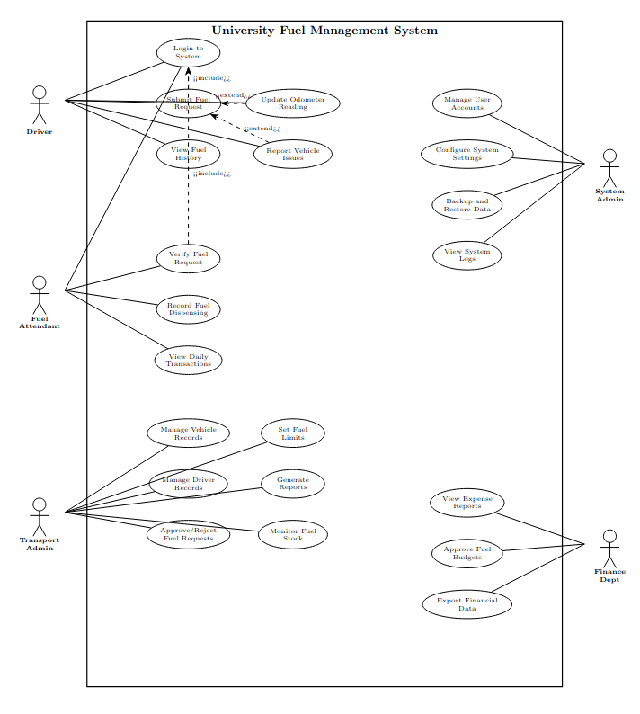
The Use Case Diagram illustrates the interactions between actors and the system functionalities. Below is the textual representation of the Use Case Diagram for the University Fuel Management System:

5.1 Actors
Actor | Description
Driver | Primary user who requests fuel and updates vehicle status
Fuel Attendant | User who dispenses fuel and records transactions
Transport Admin | Manager who approves requests and monitors consumption
System Admin | Technical user who manages system configuration
Finance Dept | User who reviews expenses and approves budgets

5.2 Use Cases by Actor
Driver Use Cases:
- Login to System
- Submit Fuel Request
- View Fuel History
- Update Odometer Reading
- Report Vehicle Issues
Fuel Attendant Use Cases:
- Login to System
- Verify Fuel Request
- Record Fuel Dispensing
- View Daily Transactions
Transport Admin Use Cases:
- Manage Vehicle Records
- Manage Driver Records
- Approve/Reject Fuel Requests
- Generate Reports
- Monitor Fuel Stock
- Set Fuel Limits
System Admin Use Cases:
- Manage User Accounts
- Configure System Settings
- Backup and Restore Data
- View System Logs
Finance Department Use Cases:
- View Expense Reports
- Approve Fuel Budgets
- Export Financial Data

6. Use Case Specifications
Detailed specifications for key use cases are provided below:

6.1 Use Case: Submit Fuel Request
Attribute | Description
Use Case ID | UC-001
Use Case Name | Submit Fuel Request
Actor | Driver
Description | Driver submits a request for fuel refill
Preconditions | Driver is logged in; Vehicle is registered
Postconditions | Fuel request is created and pending approval
Main Flow | 1. Driver selects 'New Fuel Request' 2. System displays request form 3. Driver enters vehicle ID and estimated quantity 4. Driver submits request 5. System validates and saves request 6. System confirms submission
Alternative Flow | 4a. Invalid vehicle ID: System displays error 4b. Exceeds fuel limit: System warns driver
Exception Flow | System error: Request saved as draft, notification sent to admin

6.2 Use Case: Approve Fuel Request
Attribute | Description
Use Case ID | UC-002
Use Case Name | Approve Fuel Request
Actor | Transport Admin
Description | Admin reviews and approves or rejects fuel requests
Preconditions | Admin is logged in; Pending requests exist
Postconditions | Request status updated; Driver notified
Main Flow | 1. Admin views pending requests 2. Admin selects a request 3. System displays request details 4. Admin reviews consumption history 5. Admin approves request 6. System updates status and notifies driver
Alternative Flow | 5a. Admin rejects request with reason 5b. Admin requests additional information
Exception Flow | Network error: Approval queued for retry

6.3 Use Case: Record Fuel Dispensing
Attribute | Description
Use Case ID | UC-003
Use Case Name | Record Fuel Dispensing
Actor | Fuel Attendant
Description | Attendant records actual fuel dispensed to vehicle
Preconditions | Attendant is logged in; Approved request exists
Postconditions | Transaction recorded; Stock updated
Main Flow | 1. Attendant scans/enters request ID 2. System displays approved request 3. Attendant enters odometer reading 4. Attendant dispenses fuel 5. Attendant enters actual quantity dispensed 6. System records transaction and updates stock
Alternative Flow | 2a. Request not found: Attendant searches by vehicle ID
Exception Flow | Insufficient stock: System alerts admin and records partial dispensing

6.4 Use Case: Generate Reports
Attribute | Description
Use Case ID | UC-004
Use Case Name | Generate Reports
Actor | Transport Admin, Finance Dept
Description | User generates various fuel consumption reports
Preconditions | User is logged in; Transaction data exists
Postconditions | Report generated and displayed/exported
Main Flow | 1. User selects report type 2. User specifies date range and filters 3. System queries database 4. System generates report 5. User views report 6. User exports if needed
Alternative Flow | 4a. No data found: System displays message
Exception Flow | Report generation timeout: System offers email delivery

7. Class Diagram
The Class Diagram represents the static structure of the University Fuel Management System. Below are the main classes and their attributes:

7.1 User Class
Attribute/Method | Type | Description
userId | int (PK) | Unique identifier
username | String | Login username
password | String | Encrypted password
fullName | String | User's full name
email | String | Contact email
role | Enum | User role (Driver, Admin, etc.)
isActive | Boolean | Account status
login() | Method | Authenticate user
logout() | Method | End user session

7.2 Vehicle Class
Attribute/Method | Type | Description
vehicleId | int (PK) | Unique identifier
registrationNumber | String | Vehicle registration number
make | String | Vehicle manufacturer
model | String | Vehicle model
year | int | Manufacturing year
fuelCapacity | double | Fuel tank capacity in liters
currentOdometer | int | Current odometer reading
status | Enum | Vehicle status (Active, Maintenance, etc.)
assignedDriverId | int (FK) | Reference to assigned driver

7.3 FuelRequest Class
Attribute/Method | Type | Description
requestId | int (PK) | Unique identifier
vehicleId | int (FK) | Reference to vehicle
driverId | int (FK) | Reference to requesting driver
requestDate | DateTime | Date and time of request
estimatedQuantity | double | Estimated fuel needed
status | Enum | Request status (Pending, Approved, etc.)
approvedBy | int (FK) | Admin who approved
approvalDate | DateTime | Date of approval

7.4 FuelTransaction Class
Attribute/Method | Type | Description
transactionId | int (PK) | Unique identifier
requestId | int (FK) | Reference to fuel request
vehicleId | int (FK) | Reference to vehicle
attendantId | int (FK) | Reference to fuel attendant
transactionDate | DateTime | Date and time of fueling
odometerReading | int | Odometer at fueling
quantityDispensed | double | Actual fuel dispensed
unitPrice | decimal | Price per liter
totalCost | decimal | Total transaction cost

7.5 Class Relationships
Relationship | Description
User 1:N Vehicle | One driver can be assigned to one vehicle; Admin can manage many
Vehicle 1:N FuelRequest | One vehicle can have multiple fuel requests
User 1:N FuelRequest | One driver can submit multiple requests
FuelRequest 1:1 FuelTransaction | Each approved request results in one transaction
User 1:N FuelTransaction | One attendant can record multiple transactions

8. Conclusion
This document has presented the requirement elicitation and analysis for the University Fuel Management System at FAST National University Of Computing And Emerging Sciences. The system aims to modernize fuel management processes by replacing manual record-keeping with an efficient digital solution.
The functional requirements cover all essential operations including user management, vehicle tracking, fuel request processing, and comprehensive reporting. The non-functional requirements ensure the system meets quality standards for performance, security, and usability.
The UML diagrams (Use Case and Class) provide a clear visualization of system interactions and structure, serving as a foundation for the design and implementation phases of the project.
Future tasks will build upon this foundation to develop detailed design specifications, database schema, and ultimately implement the working system.

